FIRST-TIME MICROSOFT AUTHENTICATOR SETUP
NOTE: In this procedure you will be performing tasks on your mobile device and your PC. If you have any problems with these instructions, use chat or call the Help Desk for assistance.

These instructions are to be used when you have not previously had a Microsoft Authenticator and you would like to set it up on your phone (or other mobile device). Microsoft Authenticator is available for Apple iOS and Android devices (there is not currently support for PC or Mac).

- On your mobile device, install Microsoft Authenticator app from either the Play Store or Apple Store. Do not open it yet.

- On your PC, go to this page: https://aka.ms/setupsecurityinfo
You will be prompted for your Lumen email address. You may need to use CUID@Lumen.com if you don’t have a Lumen.com email address.
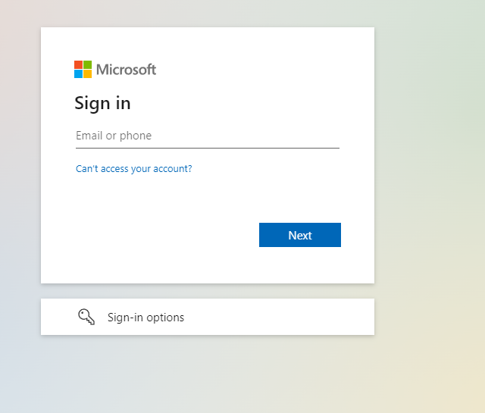
- Click the “Sign-in” button after you have entered your domain (may be called your Lumen) password.
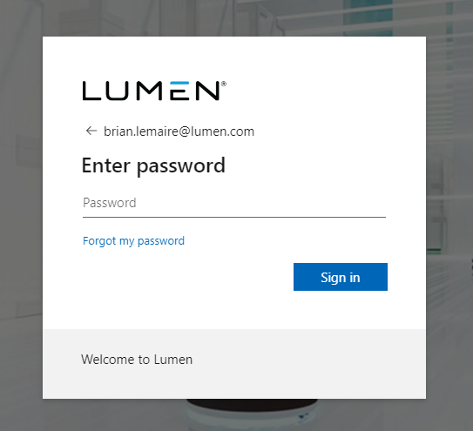
- The next screen is informing you that this system requires MFA. Click the “Next” button
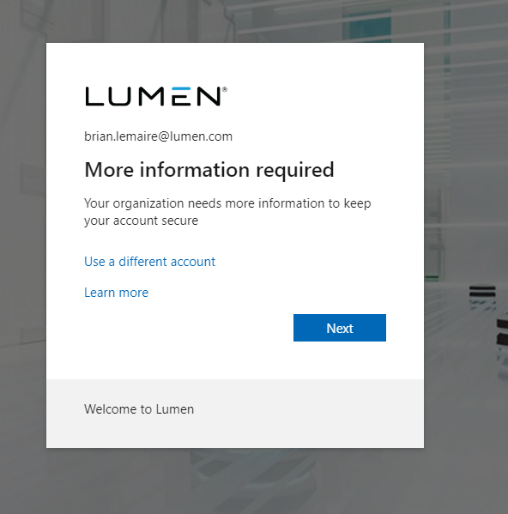

- If you don’t already have the Microsoft Authenticator application on your mobile device, download it from your application store for the device you are using. When you are ready, click the “Next” button on this screen:
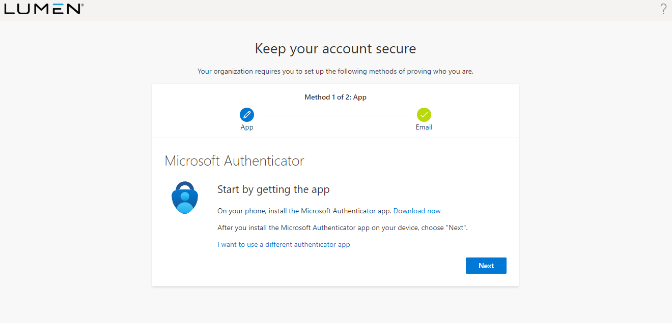

- Go to your phone and follow these steps.
  - Open the Microsoft Authenticator app.
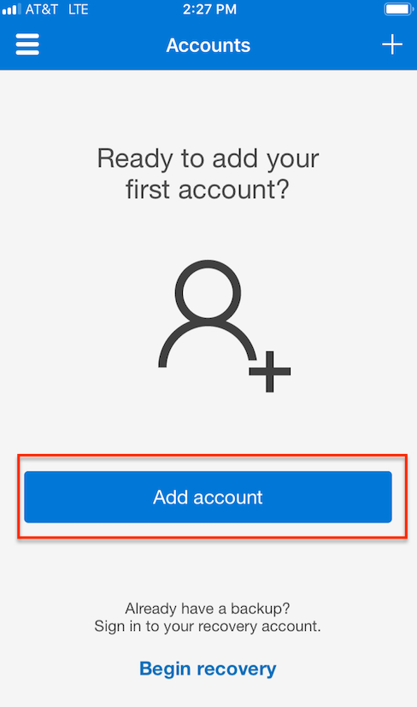
  - Tap Add Account. The Add Account window appears.
NOTE: On Android devices, tap the three dots, then Add account.
IMPORTANT: You may receive a prompt asking whether to allow the app to access your camera (iOS) or to allow the app to take pictures and record video (Android). You MUST select Allow so the Authenticator app can access your camera to take a picture of the QR code in the next step.
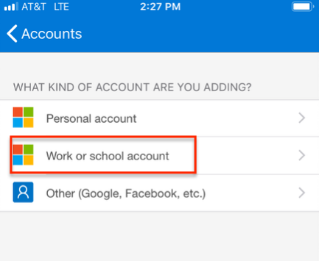
  - Tap Work or school account. The QR code scanner on your phone opens.
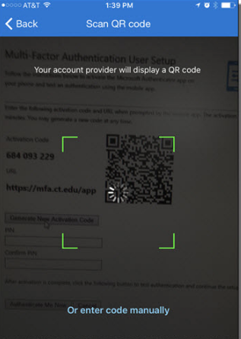
You should see the token get added to your mobile device.
- Back on the PC, click the “Next” button on this screen. On your phone, click the “+” button or add (depending on device type) to add an account on your mobile device. Then select work or school account on your mobile device.
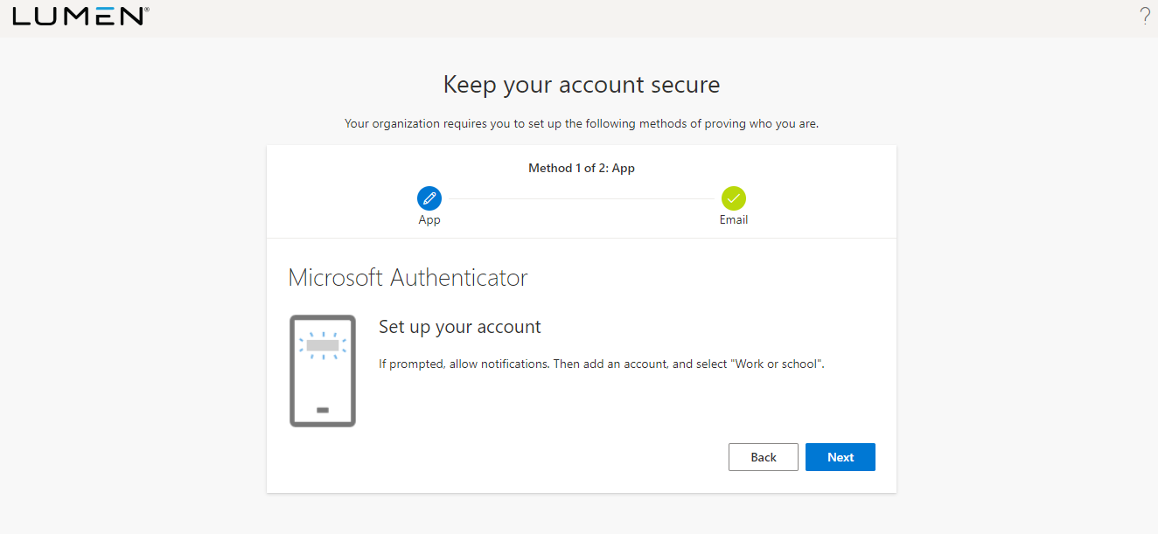
- Now you can scan the QR code from your phone and you will see the token get added. Back on the PC click the “next” button.
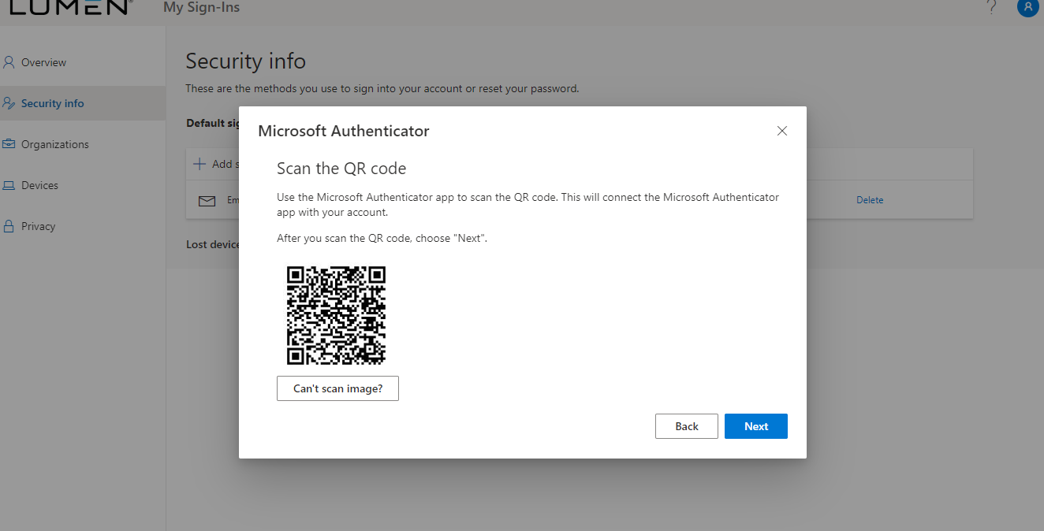
- The system will then send an approve request to your mobile device. Depending on how your device is configured or what features it supports, you may need to unlock the screen with your unlock code, use TouchID, or FaceID to approve the request.

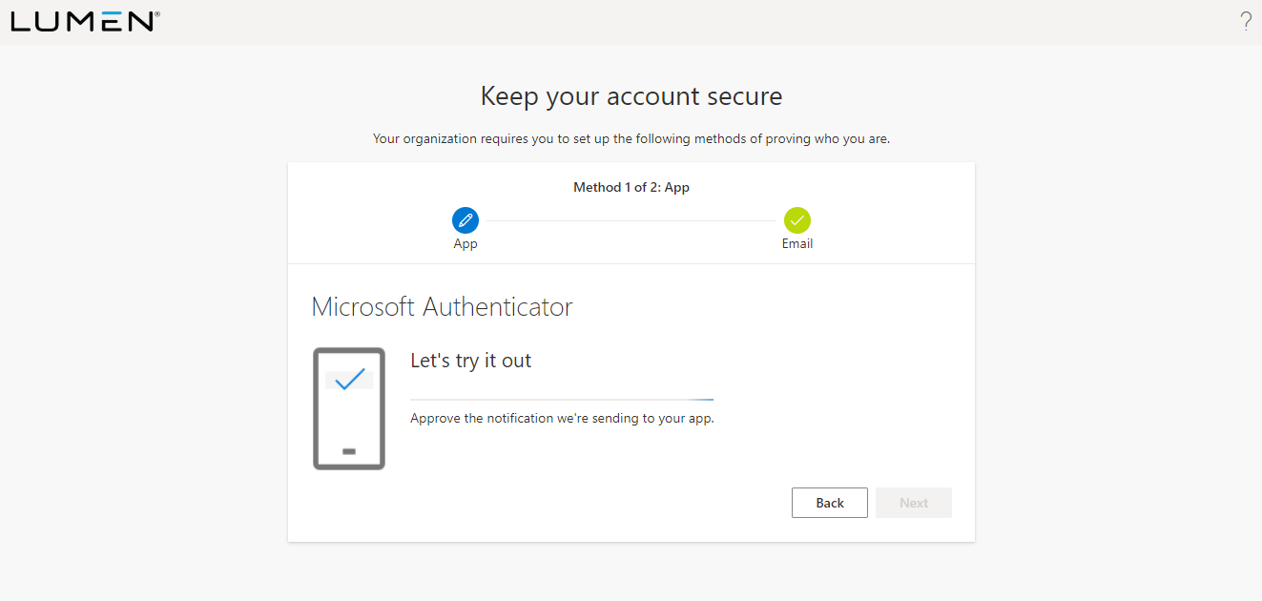

- Once approved, the screen will report a success. Click the “Next” button.
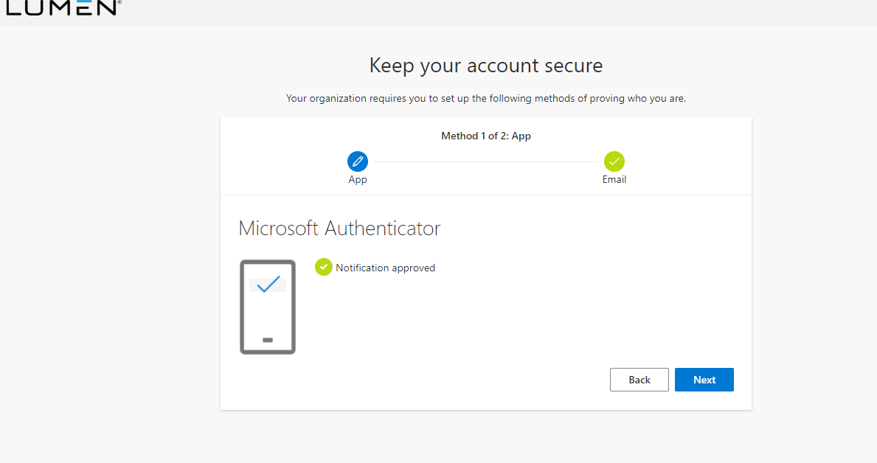

- You will then see this screen indicating a successful token registration.
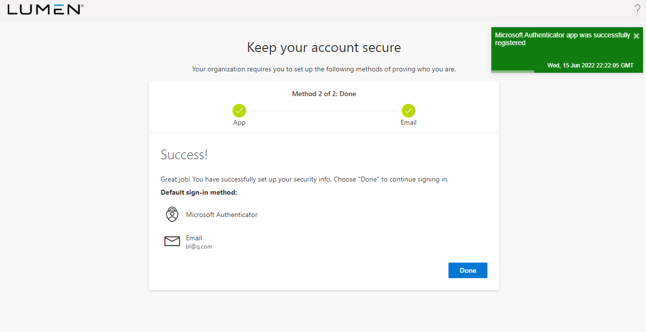
- Click Next. The Email setup window appears.
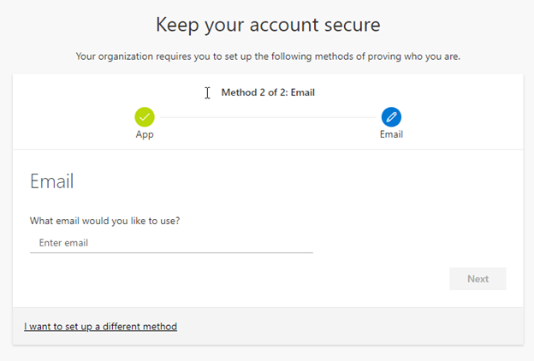
- Enter your e-mail address in the Enter email field (you cannot use a Lumen.com email address in this field. This needs to be a personal, vendor, or other email address.)
NOTE: If you wish to add Security Questions instead of an e-mail address you can click the "I want to setup up a different method" link. Please note that the following instructions will only show the Email method.
  - Click Next. An e-mail is sent to the address you entered and the following window appears.
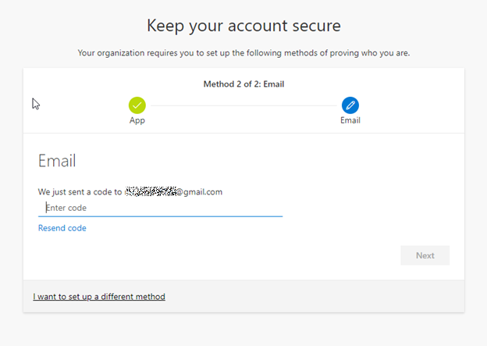
- Enter the code provided in the e-mail message in the Enter code box.
- Click Next. The Success window appears.
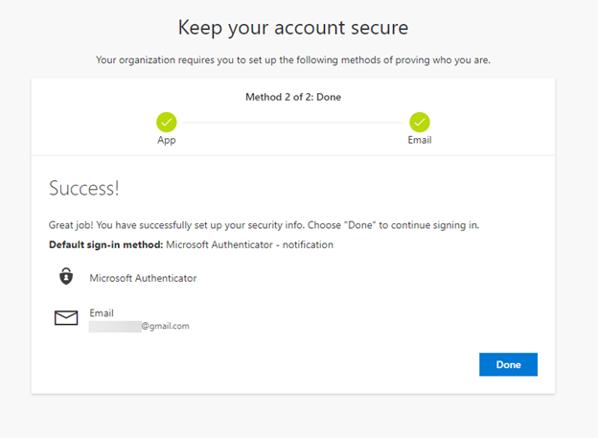
- Click Done. You are now registered to use the Microsoft Authenticator application.
- If you have any problems getting the token registered, please contact the Help Desk.

MS Authenticator Setup Document Version 1.2
- 6/15/22 – Updated with Lumen logos and made minor corrections.
- 2/24/21 – Changed site from aka.ms/mfasetup to aka.ms/setupsecurityinfo per Helpdesk request.

