Mobile Phone
How to Set Up Mobile Pass+ Authentication for Login to Global Protect or MyWorkSpace
Mobile Pass+ provides a one-time use token that can be used to log into Global Protect or MyWorkSpace.
What You Need
- An IOS or Android mobile phone.
- SafeNet MobilePASS+ downloaded from your App Store. Don’t open the app yet.
- Your email from noreply@us.safenetid.com with the subject CenturyLink Authentication Service Self-enrollment. You will need to open this email on your mobile phone. If you cannot access Century Link email on your phone, you can forward the email to a personal email account.
Enroll Mobile Pass+
- From your phone, open the email from Safenet Trusted Access/noreply@us.safenetid.com You’ll see the words
To enroll the software token on your mobile device, go to the following URL: Click the URL below that sentence.
SAMPLE EMAIL:
Your SafeNet MobilePASS+ software token has been created.
To enroll the software token on your mobile device, go to the following URL:
https://cloud.us.safenetid.com/selfEnrollment/index.aspx?code=xxxxxxxxxxxxxxxxxxxxxxxxxx
If you do not have access to Lumen email on your mobile device you can forward this message to a personal email. This new token will NOT replace your SecurID/NacID/NacPASS/SMS token, please do not remove them. If you have questions about the process you can go to this website MFA FAQ for further information.

- You’ll see the following. (Please note that this picture is from an IOS phone. It may look a little different on an Android phone.)
- You should have already downloaded the app. If not you can click on the icon to download the app. Don’t open the app yet.
- Click on Enroll your MobilePass+ token

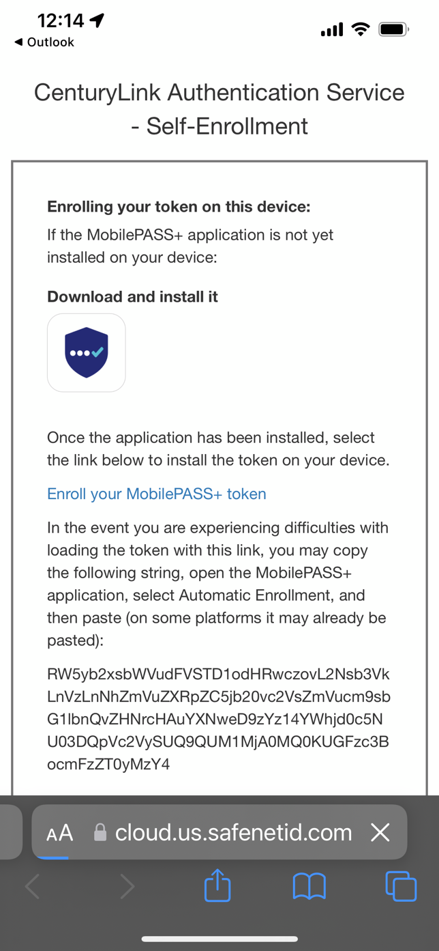

You’ll be asked to open the link using MobilePASS+. Click Open.
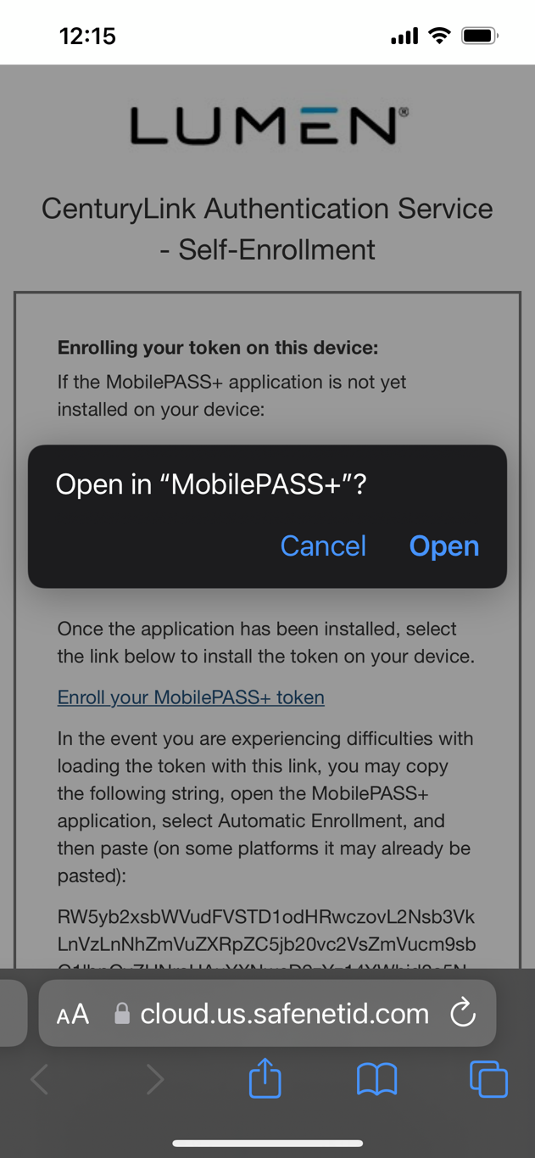

You’ll see this screen. Click Activate
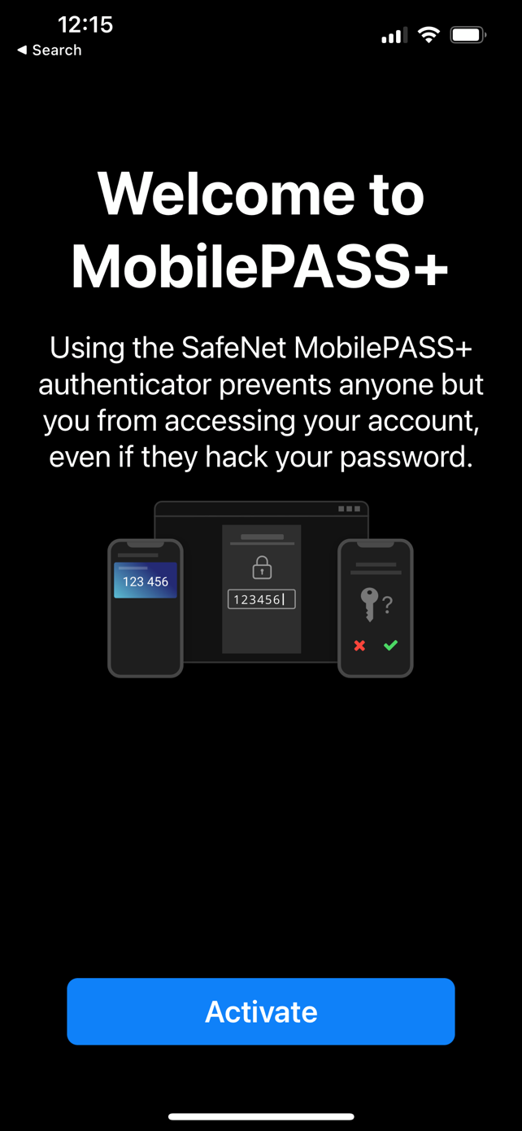

Click Next.
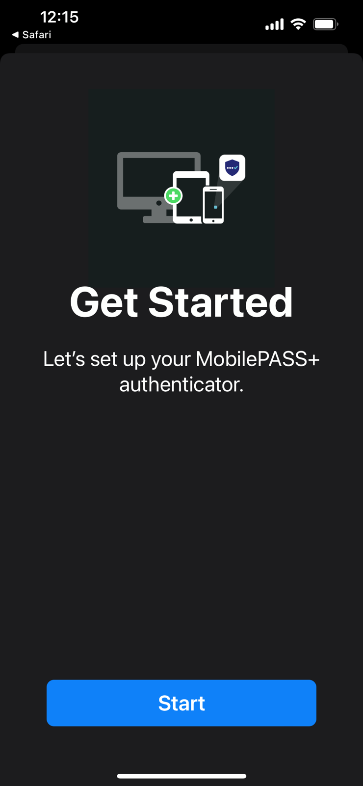

You’ll be taken to a new screen that says “Activating”

Next, set up a 4 numeric character pin code of your choosing. Confirm pin then click OK. Remember your pin code.
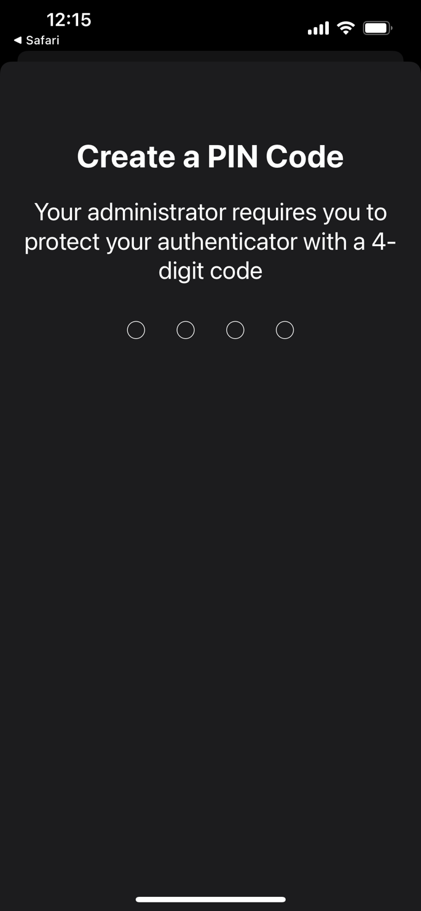

You can choose to use TouchID or FaceID (if enabled on your phone already) instead of the pin code.
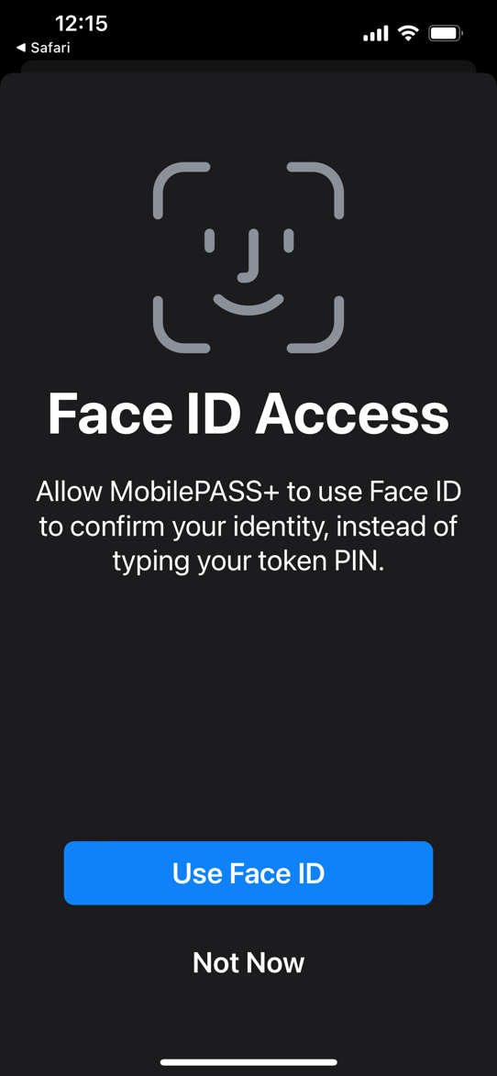

Once finished, you’ll be taken to a screen that shows your 6 digit passcode and you should be able to log into Global Protect/Citrix MyWorkspace, etc.

