Mobilepass+ 2.0 for Lumen Windows 10 PC
How to Set Up MobilePass+ 2.0 Authenticator
** The preferred method for Lumen Multifactor authentication is Microsoft Authenticator
What You Need
- Your CTL Owned and Imaged Windows 10 PC. MobilePass+ cannot be installed on Windows 7 machines.
- Your email from SafeNet Trusted Access Mailer <MFA@mfa.centurylink.com> with the subject CenturyLink Authentication Service Self-enrollment
First, Download MobilePass+
- From your CTL Windows 10 PC, open the email from SafeNet Trusted Access Mailer <MFA@mfa.centurylink.com> with the subject CenturyLink Authentication Service Self-enrollment. Click on the URL.
SAMPLE EMAIL
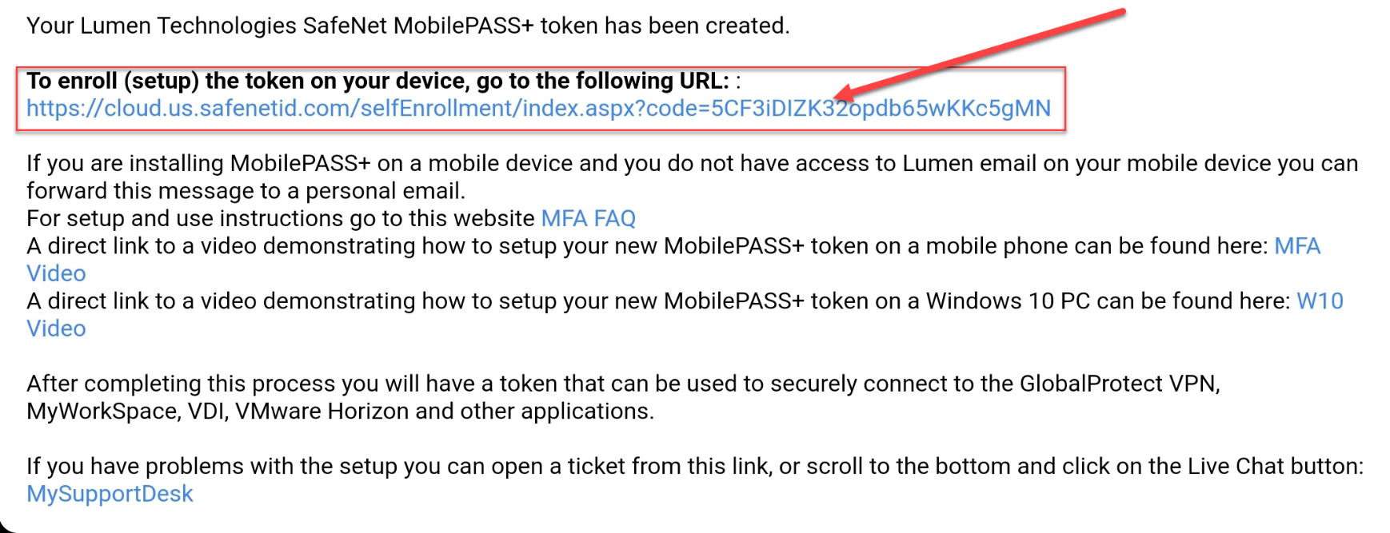
- You’ll see this screen. If you haven’t already downloaded MobilePass+ click on the Blue icon. If you have already downloaded MobilePass+ proceed to the next section – Enroll Your MobilePass+ Token.
https://mfa.centurylink.com/Documents/GemaltoApp/MobilePASS%20Setup_1.9.1.0.msi
- To begin installation click on Blue Shield
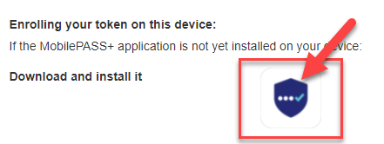

- Click on the download (bottom of browser) 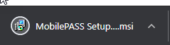

- Click Next on Welcome Screen
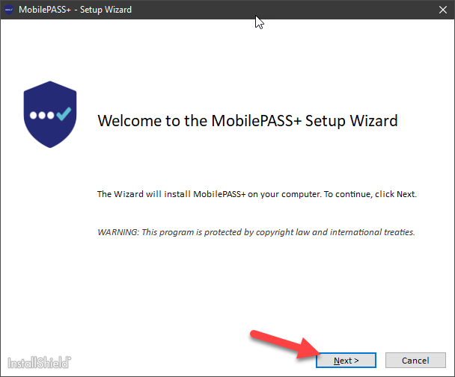

- Accept Terms and NEXT

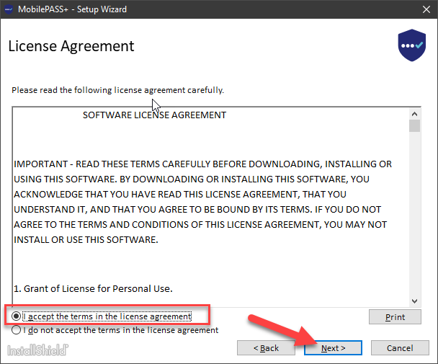

- Select Standard Config
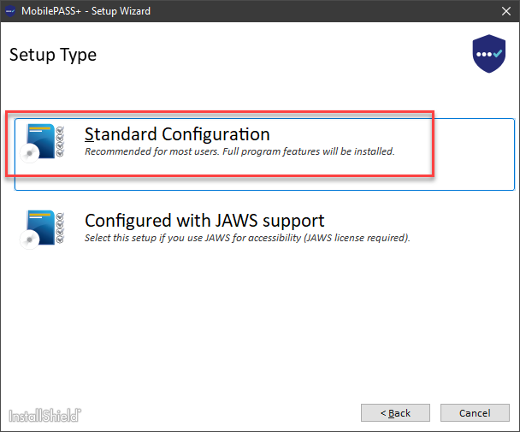

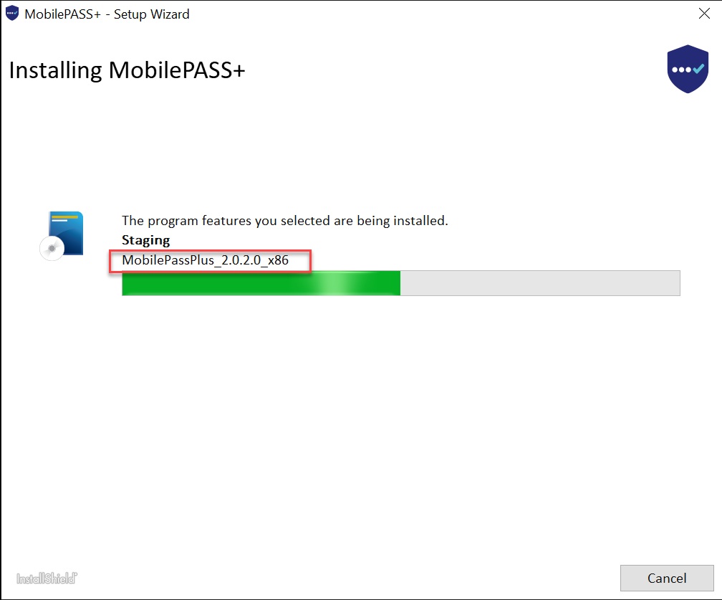

- Finish
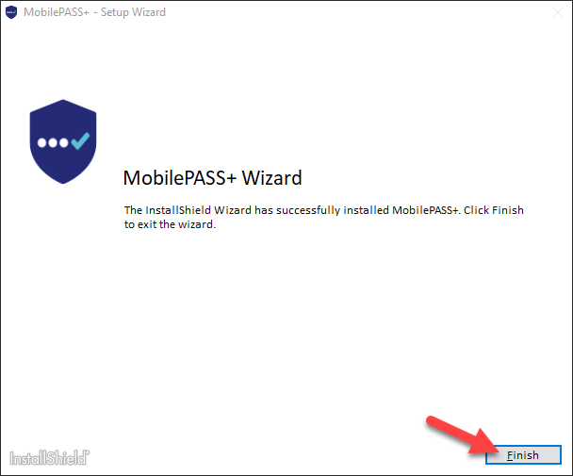

Next, Enroll Your MobilePass+ token ** You MUST close the Mobile APP on your desktop before enrolling !!
- With the APP Closed on your Desktop, Go back to the Enrollment page and click on the “Enroll your MobilePASS+ token”
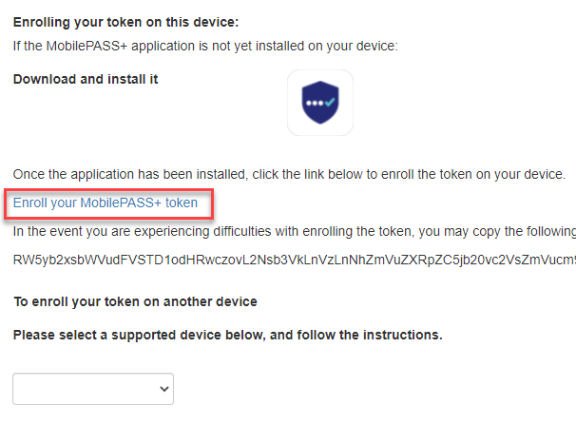

- When MobilePASS+ opens, select Start, Continue, Continue, Activating.
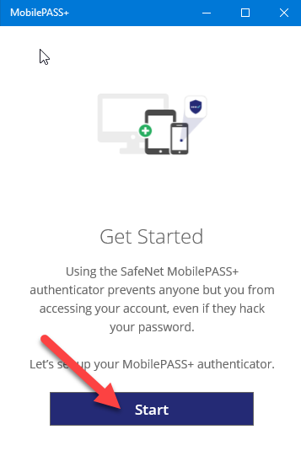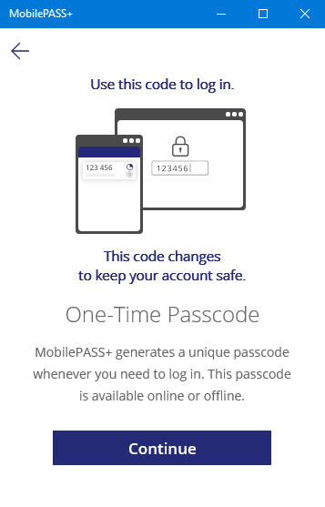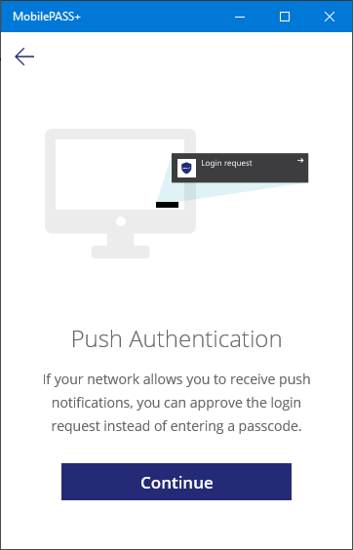

- Create a 4 digit pin code of your choosing. It cannot contain any patterns. Then click Save PIN code. Remember your pin code. You will use it every time you log in.
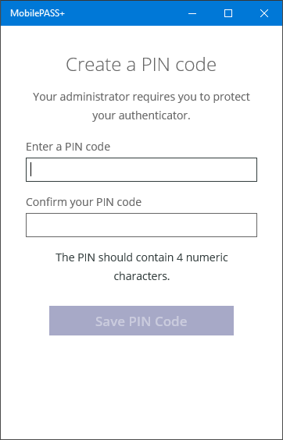
Your MobilePASS+ will now be ready for use. When using the token, be sure to use your saved PIN each time.
Sample of use:
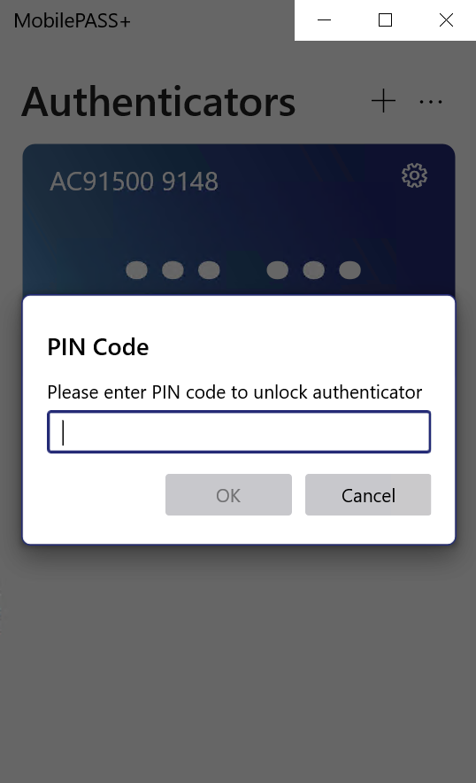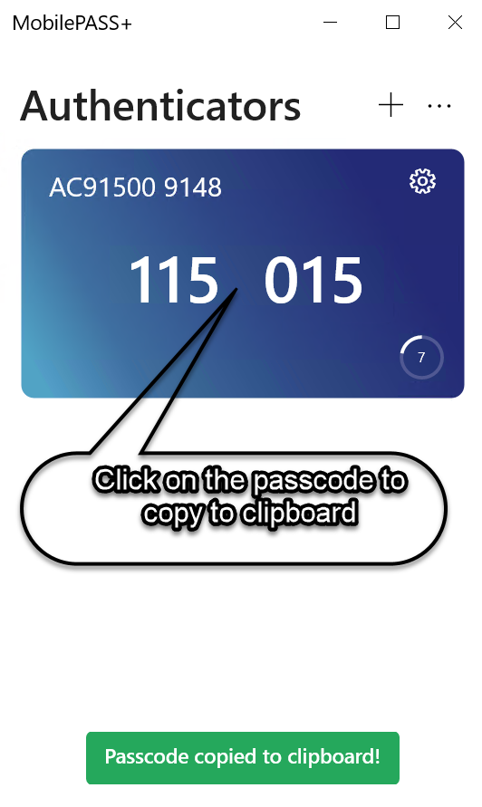

App Version | Doc Version | Date | Author | Revision Description
2.0 | 1.0 | 10/14/2021 | Michael Hackett | Created New Document for MobilePass+
 | 1.1

