NEED MICROSOFT AUTHENTICATOR FOR REPLACEMENT PHONE
NOTE: In this procedure you will be performing tasks on your mobile device and your PC. If you have any problems with these instructions, use chat or call the Help Desk for assistance.

These instructions are to be used when you previously had a Microsoft Authenticator and you have gotten a new or replacement mobile device.

- If you don’t still have your old phone, your Microsoft Authenticator token must be reset in Azure. You will need to contact the Help Desk via chat (if you are able to get on the corporate network) or via phone at 877-828-4357. Let the agent know you got a new phone and need your Microsoft Authenticator token reset. They will reset the account and should be able to walk you through the steps using the registration page: https://aka.ms/setupsecurityinfo to get a NEW Microsoft Authenticator token.

- If you still have your old phone, you can use the token on that phone to login to the Microsoft Authenticator registration page.
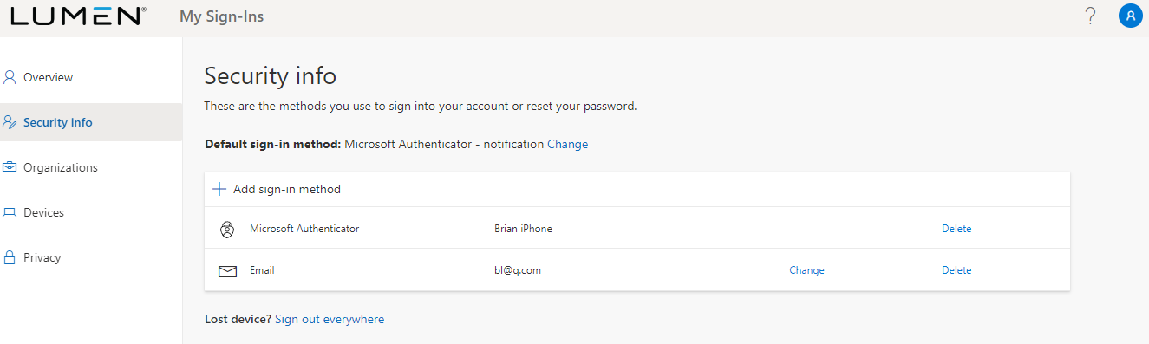

- First, delete any old Microsoft Authenticator tokens you might have. There is a limit of 5 so minimizing this list to only the current token you have is a good idea. Click the Delete button and then confirm on the next screen:
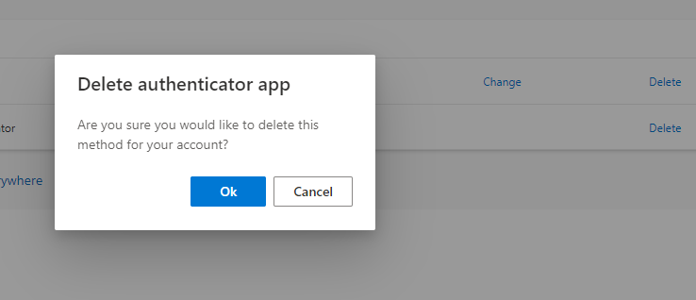

- Once you have deleted old tokens, you can then click “Add sign-in method” to add a new authenticator.

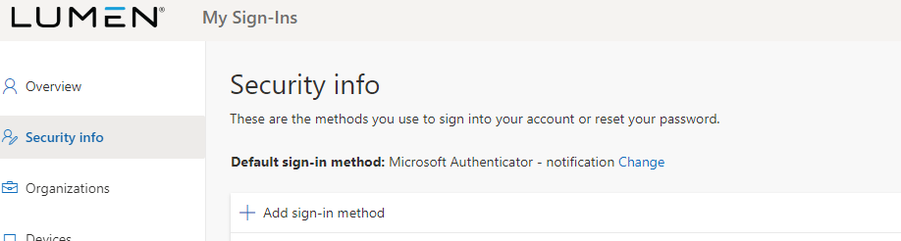

- Use the pulldown on the “Add a method” window to select “Authenticator app” and then click the “Add” button.

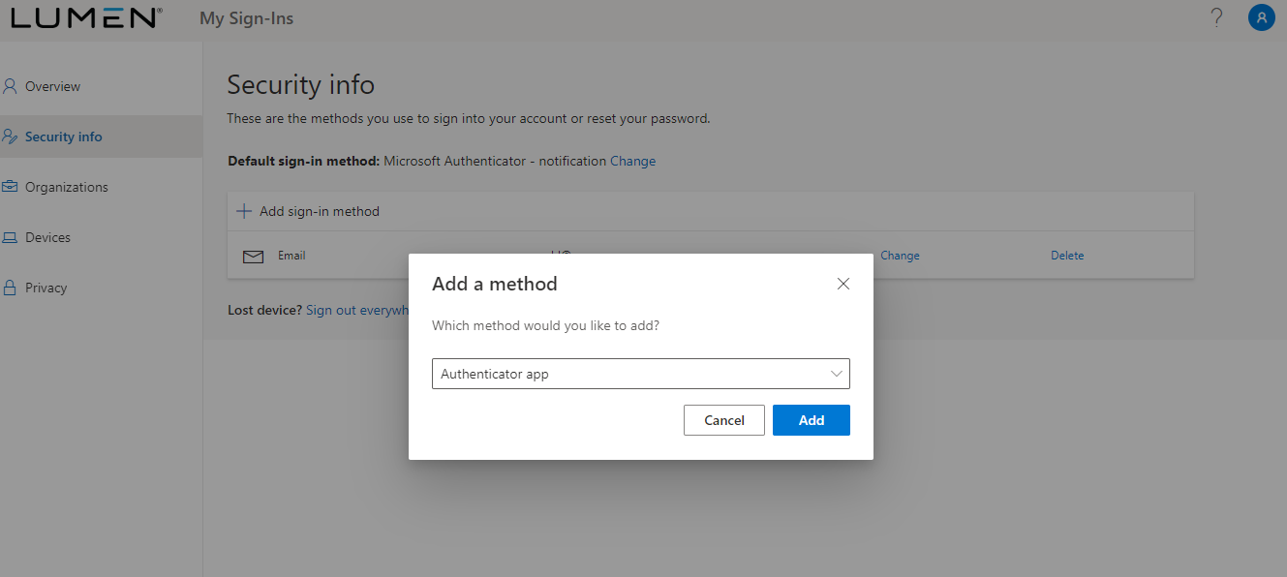

  - Inside Microsoft Authenticator on your phone, delete the old token (but leave the application installed). On the phone, click the + (or other button depending on device type) to add a new token to your phone. NOTE: On Android devices, tap the three dots, then Add account.
IMPORTANT: You may receive a prompt asking whether to allow the app to access your camera (iOS) or to allow the app to take pictures and record video (Android). You MUST select Allow so the Authenticator app can access your camera to take a picture of the QR code in the next step.
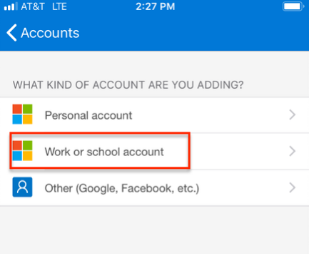
  - Tap Work or school account. The QR code scanner on your phone opens.
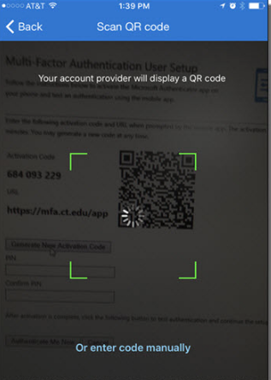

- Back on the laptop, click “Next”

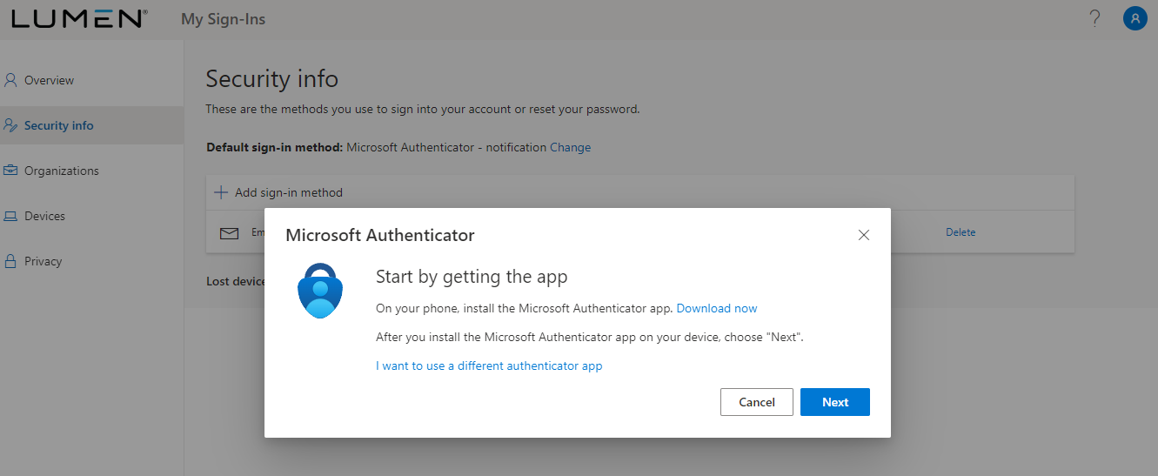
- Click Next on this screen:
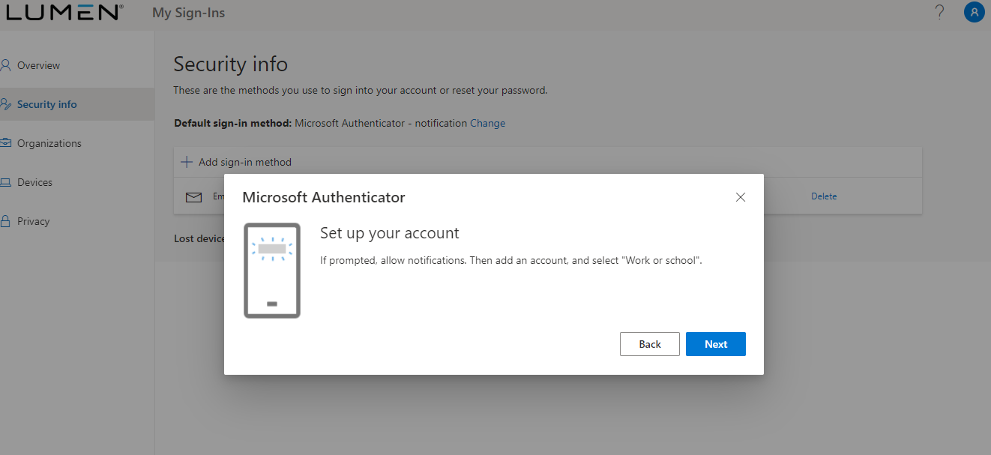

- Now you can scan the QR code from your phone and you will see the token get added. Back on the PC click the “next” button.
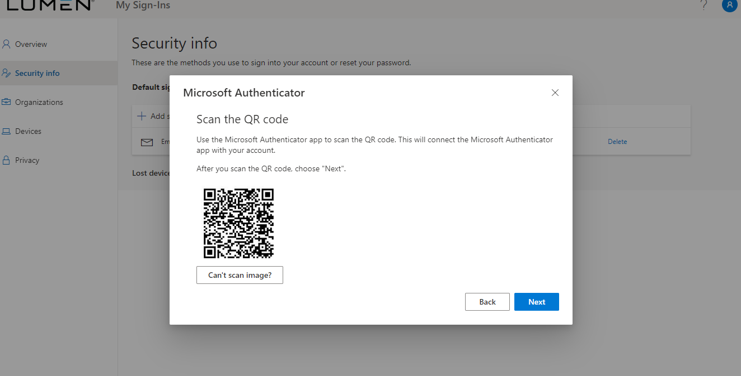
- The system will then send an approve request to your mobile device. Depending on how your device is configured or what features it supports, you may need to unlock the screen with your unlock code, use TouchID, or FaceID to approve the request.

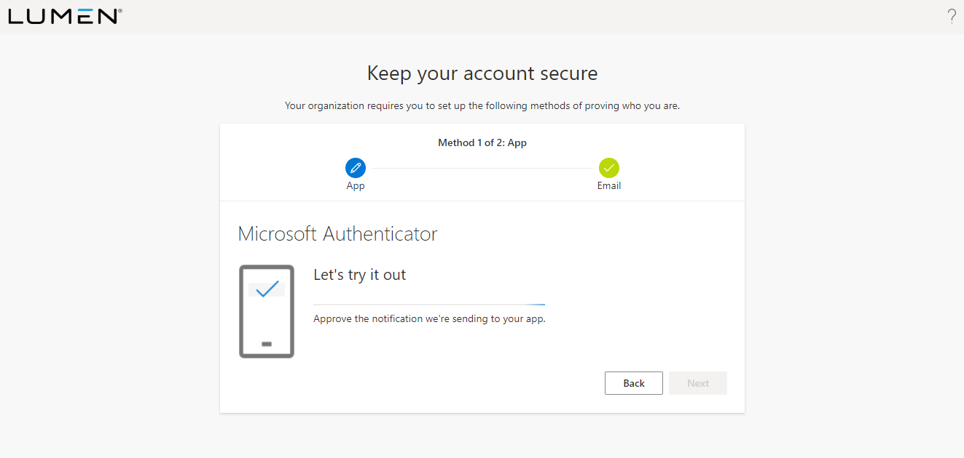

- Once approved, the screen will report a success. Click the “Next” button.
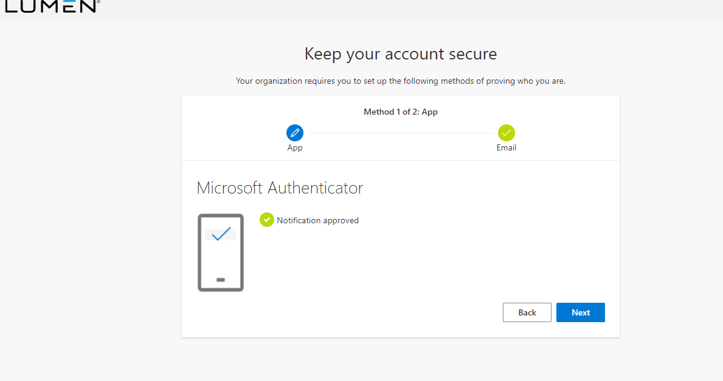

- You will then see this screen indicating a successful token registration. You can now use your token to log in to Lumen applications that use Microsoft Authenticator.

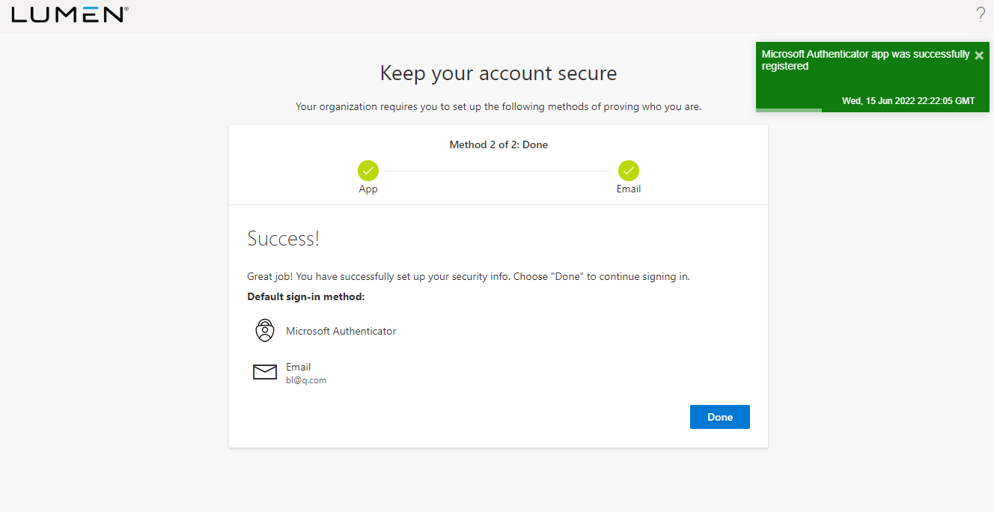

- If you have any problems getting the token registered, please contact the Help Desk.

MS Authenticator Replacement Device Setup Document Version 1.1
- 6/15/22 – First version.

