

**Using Microsoft Authenticator to Log In to CTL Jump Hosts**

**Preparation**

1. Ensure you have Microsoft Authenticator set up on your mobile device. If not, go to httsp://mfa.centurylink.com for Microsoft Authenticator set up instructions.

**2.** Once Microsoft Authenticator is set up, you will need to self-elect to use Microsoft Authenticator for GlobalProtect and other CTL applications. Go to <https://mysupportdesk.service-now.com/msd?id=sc_cat_item&sys_id=167c4496db65dcd0b36cd12c5e961970> . Select the Microsoft Authenticator option from the “Preferred Token Type” drop down menu. Click the submit button.

**Log In To CTL Jump Hosts**

While working remotely, you can use Microsoft Authenticator to log in to CTL jump hosts that you are already authorized for.

1. Go to the jump host login screen. Enter your **CUID** and **domain password** as normal.

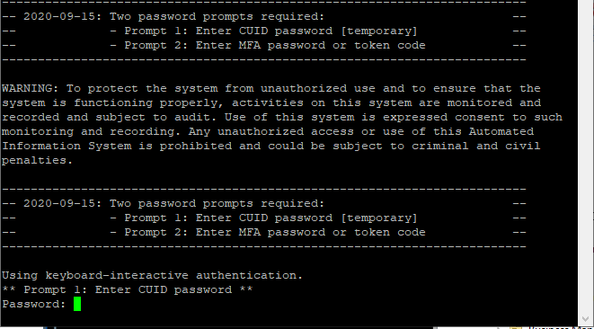

Enter your domain password here

2. Open the Authenticator  app on your mobile device. Wait a few seconds until you see the approval request. Click Approve and you will be logged into the jump host. Please note that you must already be authorized for the jump host you are trying to log into. If you are unable to log in, please contact your jump host administrator.



Using Microsoft Authenticator to Access Jumphosts - Verison 1.1

* Changed references to the single token select form from mobilepass.corp.intranet